Insertion Sort

Insertion sort is a simple sorting algorithm that works similar to the way you sort playing cards in your hands. The array is virtually split into a sorted and an unsorted part. Values from the unsorted part are picked and placed at the correct position in the sorted part.
Algorithm
To sort an array of size n in ascending order:
1: Iterate from arr[1] to arr[n] over the array.
2: Compare the current element (key) to its predecessor.
3: If the key element is smaller than its predecessor, compare it to the elements before. Move the greater elements one position up to make space for the swapped element.
Example:
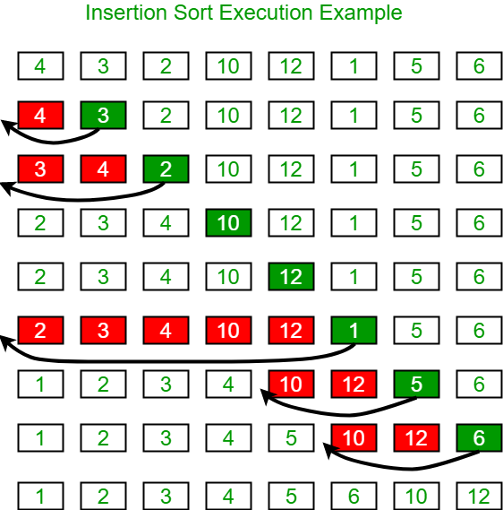
insertion-sort

Another Example:
12, 11, 13, 5, 6
Let us loop for i = 1 (second element of the array) to 4 (last element of the array)
i = 1. Since 11 is smaller than 12, move 12 and insert 11 before 12
11, 12, 13, 5, 6
i = 2. 13 will remain at its position as all elements in A[0..I-1] are smaller than 13
11, 12, 13, 5, 6
i = 3. 5 will move to the beginning and all other elements from 11 to 13 will move one position ahead of their current position.
5, 11, 12, 13, 6
i = 4. 6 will move to position after 5, and elements from 11 to 13 will move one position ahead of their current position.
5, 6, 11, 12, 13

// C++ program for insertion sort
#include <bits/stdc++.h>
using namespace std;

/* Function to sort an array using insertion sort*/
void insertionSort(int arr[], int n)
{
int i, key, j;
for (i = 1; i < n; i++)
{
key = arr[i];
j = i - 1;

/* Move elements of arr[0..i-1], that are
greater than key, to one position ahead
of their current position */
while (j >= 0 && arr[j] > key)
{
arr[j + 1] = arr[j];
j = j - 1;
}
arr[j + 1] = key;
}
}

// A utility function to print an array of size n
void printArray(int arr[], int n)
{
int i;
for (i = 0; i < n; i++)
cout << arr[i] << " ";
cout << endl;
}

/* Driver code */
int main()
{
int arr[] = { 12, 11, 13, 5, 6 };
int n = sizeof(arr) / sizeof(arr[0]);

insertionSort(arr, n);
printArray(arr, n);

return 0;
}

Output:
5 6 11 12 13
Time Complexity: O(n*2)
Auxiliary Space: O(1)
Boundary Cases: Insertion sort takes maximum time to sort if elements are sorted in reverse order. And it takes minimum time (Order of n) when elements are already sorted.
Algorithmic Paradigm: Incremental Approach
Sorting In Place: Yes
Stable: Yes
Online: Yes
Uses: Insertion sort is used when number of elements is small. It can also be useful when input array is almost sorted, only few elements are misplaced in complete big array.
What is Binary Insertion Sort?
We can use binary search to reduce the number of comparisons in normal insertion sort. Binary Insertion Sort uses binary search to find the proper location to insert the selected item at each iteration. In normal insertion, sorting takes O(i) (at ith iteration) in worst case. We can reduce it to O(logi) by using binary search. The algorithm, as a whole, still has a running worst case running time of O(n^2) because of the series of swaps required for each insertion. Refer this for implementation.
How to implement Insertion Sort for Linked List?
Below is simple insertion sort algorithm for linked list.
1) Create an empty sorted (or result) list
2) Traverse the given list, do following for every node.
......a) Insert current node in sorted way in sorted or result list.
3) Change head of given linked list to head of sorted (or result) list.

Insertion Sort for Singly Linked List

Below is simple insertion sort algorithm for linked list.

1) Create an empty sorted (or result) list
2) Traverse the given list, do following for every node.
......a) Insert current node in sorted way in sorted or result list.
3) Change head of given linked list to head of sorted (or result) list.
Recommended: Please try your approach on {IDE} first, before moving on to the solution.
The main step is (2.a) which has been covered in below post.
Sorted Insert for Singly Linked List

Below is implementation of above algorithm

/* C program for insertion sort on a linked list */
#include<stdio.h>
#include<stdlib.h>

/* Link list node */
struct Node
{
int data;
struct Node* next;
};

// Function to insert a given node in a sorted linked list
void sortedInsert(struct Node**, struct Node*);

// function to sort a singly linked list using insertion sort
void insertionSort(struct Node **head_ref)
{
// Initialize sorted linked list
struct Node *sorted = NULL;

// Traverse the given linked list and insert every
// node to sorted
struct Node *current = *head_ref;
while (current != NULL)
{
// Store next for next iteration
struct Node *next = current->next;

// insert current in sorted linked list
sortedInsert(&sorted, current);

// Update current
current = next;
}

// Update head_ref to point to sorted linked list
*head_ref = sorted;
}

/* function to insert a new_node in a list. Note that this
function expects a pointer to head_ref as this can modify the
head of the input linked list (similar to push())*/
void sortedInsert(struct Node** head_ref, struct Node* new_node)
{
struct Node* current;
/* Special case for the head end */
if (*head_ref == NULL || (*head_ref)->data >= new_node->data)
{
new_node->next = *head_ref;
*head_ref = new_node;
}
else
{
/* Locate the node before the point of insertion */
current = *head_ref;
while (current->next!=NULL &&
current->next->data < new_node->data)
{
current = current->next;
}
new_node->next = current->next;
current->next = new_node;
}
}

/* BELOW FUNCTIONS ARE JUST UTILITY TO TEST sortedInsert */

/* Function to print linked list */
void printList(struct Node *head)
{
struct Node *temp = head;
while(temp != NULL)
{
printf("%d ", temp->data);
temp = temp->next;
}
}

/* A utility function to insert a node at the beginning of linked list */
void push(struct Node** head_ref, int new_data)
{
/* allocate node */
struct Node* new_node = new Node;

/* put in the data */
new_node->data = new_data;

/* link the old list off the new node */
new_node->next = (*head_ref);

/* move the head to point to the new node */
(*head_ref) = new_node;
}

// Driver program to test above functions
int main()
{
struct Node *a = NULL;
push(&a, 5);
push(&a, 20);
push(&a, 4);
push(&a, 3);
push(&a, 30);

printf("Linked List before sorting \n");
printList(a);

insertionSort(&a);

printf("\nLinked List after sorting \n");
printList(a);

return 0;
}

Output:
Linked List before sorting
30 3 4 20 5
Linked List after sorting
3 4 5 20 30

Given a linked list which is sorted, how will you insert in sorted way
Given a sorted linked list and a value to insert, write a function to insert the value in a sorted way.

Initial Linked List
SortedLinked List

Linked List after insertion of 9
UpdatedSortedLinked List

Recommended: Please solve it on “PRACTICE” first, before moving on to the solution.

Algorithm:
Let input linked list is sorted in increasing order.
1) If Linked list is empty then make the node as
head and return it.
2) If the value of the node to be inserted is smaller
than the value of the head node, then insert the node
at the start and make it head.
3) In a loop, find the appropriate node after
which the input node (let 9) is to be inserted.
To find the appropriate node start from the head,
keep moving until you reach a node GN (10 in
the below diagram) who's value is greater than
the input node. The node just before GN is the
appropriate node (7).
4) Insert the node (9) after the appropriate node
(7) found in step 3.
Implementation:

/* Program to insert in a sorted list */
#include <bits/stdc++.h>
using namespace std;

/* Link list node */
class Node {
public:
int data;
Node* next;
};

/* function to insert a new_node
in a list. Note that this
function expects a pointer to
head_ref as this can modify the
head of the input linked list
(similar to push())*/
void sortedInsert(Node** head_ref,
Node* new_node)
{
Node* current;
/* Special case for the head end */
if (*head_ref == NULL
|| (*head_ref)->data
>= new_node->data) {
new_node->next = *head_ref;
*head_ref = new_node;
}
else {
/* Locate the node before the
point of insertion */
current = *head_ref;
while (current->next != NULL
&& current->next->data
< new_node->data) {
current = current->next;
}
new_node->next = current->next;
current->next = new_node;
}
}

/* BELOW FUNCTIONS ARE JUST
UTILITY TO TEST sortedInsert */

/* A utility function to
create a new node */
Node* newNode(int new_data)
{
/* allocate node */
Node* new_node = new Node();

/* put in the data */
new_node->data = new_data;
new_node->next = NULL;

return new_node;
}

/* Function to print linked list */
void printList(Node* head)
{
Node* temp = head;
while (temp != NULL) {
cout << temp->data << " ";
temp = temp->next;
}
}

/* Driver program to test count function*/
int main()
{
/* Start with the empty list */
Node* head = NULL;
Node* new_node = newNode(5);
sortedInsert(&head, new_node);
new_node = newNode(10);
sortedInsert(&head, new_node);
new_node = newNode(7);
sortedInsert(&head, new_node);
new_node = newNode(3);
sortedInsert(&head, new_node);
new_node = newNode(1);
sortedInsert(&head, new_node);
new_node = newNode(9);
sortedInsert(&head, new_node);
cout << "Created Linked List\n";
printList(head);

return 0;
}
// This is code is contributed by rathbhupendra

Output:
Created Linked List
1 3 5 7 9 10
Complexity Analysis:

Time Complexity: O(n).
Only one traversal of the list is needed.
Auxiliary Space: O(1).
No extra space is needed.
Shorter Implementation using double pointers:
Thanks to Murat M Ozturk for providing this solution. Please see Murat M Ozturk’s comment below for complete function. The code uses double-pointer to keep track of the next pointer of the previous node (after which new node is being inserted).

Note that below line in code changes current to have address of next pointer in a node.

current = &((*current)->next);
Also, note below comments.

/* Copies the value-at-address current to
new_node's next pointer*/
new_node->next = *current;

/* Fix next pointer of the node (using its address)
after which new_node is being inserted */
*current = new_node;
Time Complexity: O(n)
References: http://cslibrary.stanford.edu/105/LinkedListProblems.pdf

